Putting Your iPad into Recovery Mode

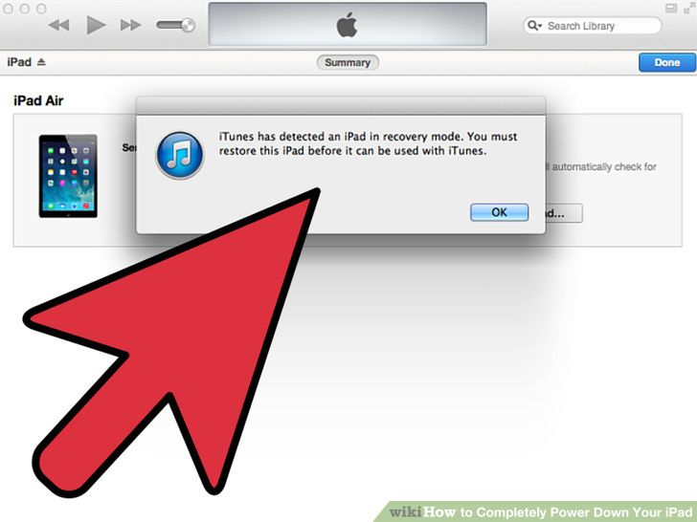

**Put your iPad into Recovery mode when you can't unfreeze it.** This should be considered a last resort, since Recovery mode may force you to wipe the iPad and set it up as new.



**Connect your iPad to your computer and open iTunes.** You'll need to use iTunes to complete the Recovery mode process.



**Press and hold the Home and Sleep/Power buttons.** After about 10 seconds, you'll see the Apple logo.

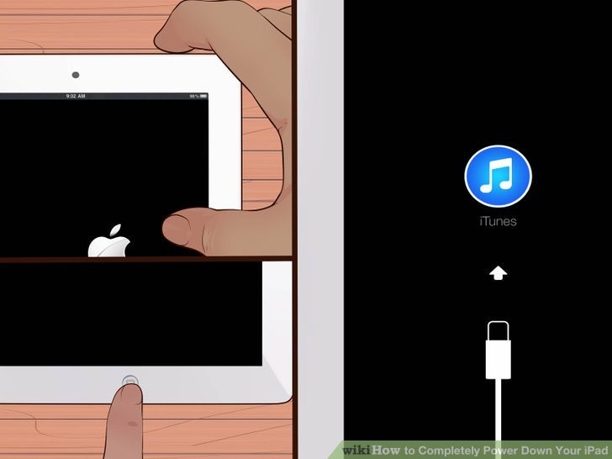

**Continue holding the Home and Sleep/Power buttons until the iTunes logo appears.** This will prompt iTunes to restore your device.

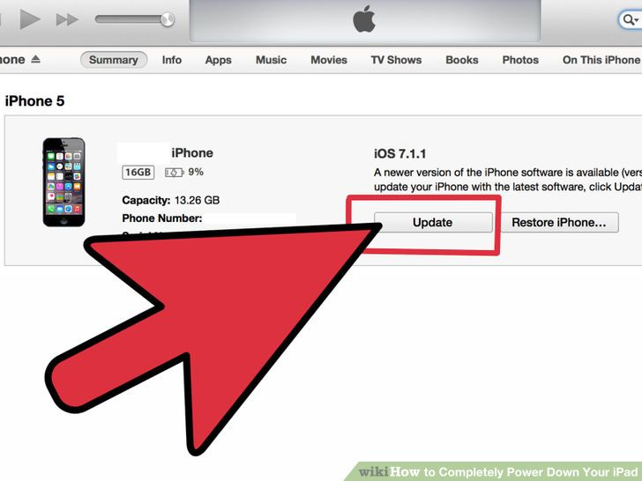

**Click "Update" when prompted in iTunes.** iTunes will attempt to download the latest update and apply it without erasing any of your data.

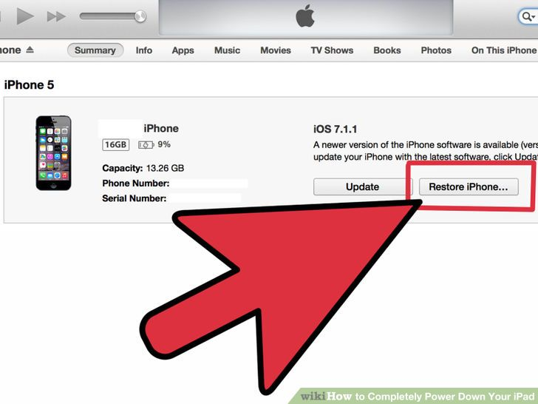

**Repeat the process and select "Restore" if the update method doesn't work.** If the update takes longer than 15 minutes to download and install, you'll likely need to repeat the Recovery mode process and select "Restore" instead of "Update" in iTunes. This will wipe the iPad's data but should get it working again.

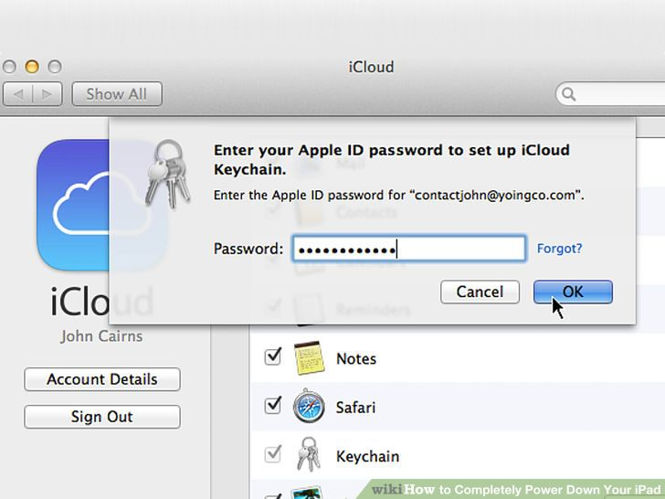

**Set up your iPad after restoring.** After the restore process is finished, you'll be taken through the initial setup for the iPad as if it were new. Enter your Apple ID to restore your iCloud data. If you're connected to the computer with your iTunes library, you can restore any available iTunes backups.